

Iteration Plan Template

eCoaching Log I1

Revision History

|  |  |  |  |
| --- | --- | --- | --- |
| **Date** | **Version** | **Description** | **Author** |
| 8/1/2014 | 0.1 | Initial Draft | Timothy Queen |
|  |  |  |  |
|  |  |  |  |
|  |  |  |  |

Contents

1. Introduction 4

2. Key milestones 4

3. High-level objectives 4

4. Work Item assignments 4

5. Issues 5

6. Evaluation criteria 5

7. Assessment and Lessons Learned 5

# Introduction

The purpose of this document is to collect, analyze, and define high-level needs and changes required to the eCoaching Log. It focuses on the capabilities needed by the stakeholders and the target users, and why these needs exist. The details of how the eCoaching Log fulfills these needs are detailed in the use-case and supplementary specifications.This project will introduce the concept of modules and add a Supervisor eCL and a Quality Specialist eCL to the system.

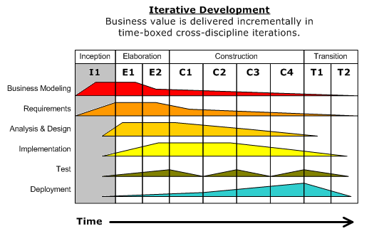

# Key milestones

| **Milestone** | **Date** |
| --- | --- |
| Iteration start | June 1, 2014 |
| * Scope concurrence - The stakeholders reach agreement as to the scope of the project |  |
| * Initial requirements definition - There is agreement that the right set of requirements have been captured, even if just at a high level, and there is a shared understanding of those requirements |  |
| * Plan concurrence - The stakeholders agree with the initial cost and schedule estimates |  |
| * Risk acceptance - The risks have been identified, assessed, and acceptable strategies to address them have been identified. |  |
| * Process acceptance - The development process has been initially tailored and agreed to by all parties |  |
| * Business case |  |
| * Project plan |  |
| Iteration stop | Aug 10 |

# High-level objectives

* *Defined functionality for the modular approach to coaching KPAs*
* *Defined functionality for the Dashboard enhancements*

# Work Item assignments

Doug Stearns will work with John Tiongson to develop user stories and use cases.

# Issues

| **Issue** | **Status** | **Notes** |
| --- | --- | --- |
|  |  |  |

# Evaluation criteria

User Stories and use cases are completed.

# Assessment and Lessons Learned

[Use this section for capturing and communicating results and actions from assessments against objectives and lessons learned, which are typically done at the end of each iteration. If you don’t do this, the team may not be able to improve the way they develop software.]

|  |  |
| --- | --- |
| Assessment target |  |
| Assessment date |  |
| Participants |  |
| Project status | *[For example, express as Red, Yellow, or Green.]* |

Assessment against objectives

* *[Document whether you addressed the objectives as specified in the Iteration Plan.]*

Work Items: Planned compared to actually completed

* *[Summarize whether all Work Items planned to be addressed in the iteration were addressed, and which Work Items were postponed or added.]*

Assessment against Evaluation Criteria Test results

* *[Document whether you met the evaluation criteria as specified in the Iteration Plan. This could include information such as “Demo for Department X was well-received, with some concerns raised around usability,” or “495 test cases were automated with a 98% pass rate. 9 test cases were deferred because the corresponding Work Items were postponed.”]*

Lessons Learned, and other concerns and deviations

*[List other areas that have been evaluated, such as process, financials, or schedule deviation, as well as Stakeholder feedback not captured elsewhere.]*